Call for Proposals
Academic User Access 2020
National Nuclear Laboratory Limited (“NNL”) would like to invite proposals from university academics for user access to a range of equipment in NNL Central Laboratory (Sellafield) focussing on research and developments associated with “Advanced Nuclear Fuels and Recycle”. The call is open from 10th July – 7th August 2020 for experiments performed in the period September 2020 to March 2021. The equipment available includes FIB-SEM, PFIB with ToF-SIMS, (S)TEM with EDS and EELS, X-ray CT and Fumehood/Glovebox Raman. NNL will cover facility and equipment costs - including supervising the experiments and equipment usage, but all other costs will be borne by the applicants (see Notes for Clarification). Full details of the opportunity are provided below.
Please note that during the current COVID-19 situation, with restrictions in place to protect public health, our lab-based work in NNL is operating on a reduced scale. Dates noted within this Call are all subject to the condition that any planned access must be possible within any Government imposed restrictions on work or travel, any imposed restrictions by the Site licensor and within any operating procedures put in place by NNL to ensure the continued safety and health of our workforce and any other visitors to our facilities.

National Nuclear Laboratory
Established in 2008, NNL brought together the UK’s nuclear research and development capability into one organisation. Our workforce represents a combined 10,000 years of expertise in nuclear science and technology. We are pioneers, innovators and experts in our field. We work globally at the forefront of nuclear science, providing knowledge, technology and access to cutting-edge facilities to partners and customers.
NNL facilitates academic research on irradiated and nuclear materials. We provide equipment, facilities and associated expertise to process and analyse materials, particularly those that are too radioactive for university laboratories including materials that can only be handled on nuclear licensed sites.
This user access call provides academics with an opportunity to apply to use specific grant funded NNL equipment situated in our “Central Laboratory” on the Sellafield site.
The NNL User Access Team provides a single point of entry into NNL facilities (access.liaison@uknnl.com).

The Advanced Fuel Cycle Programme (AFCP)
Affordable clean energy will be vital to the prosperity of the UK. In 2017, the Government articulated its commitment to decarbonising all sectors of the UK economy in its Clean Growth Strategy. A sustained cost competitive build programme (Gen III+, Small Modular Reactor - SMR and Advanced Modular Reactor - AMR) is required to meet the objectives set out in the Clean Growth Strategy. In particular, there are significant opportunities for the UK in relation to Advanced Nuclear Technologies (SMRs and AMRs) both domestically and globally. UK involvement at an early stage maximises the prospects for UK jobs, Intellectual Property and supply chain development. If the UK is to contribute to the deployment of attractive solutions in the clean energy market timeframe there is a real need to accelerate the programmes, collaborate effectively, and realise the benefits of delivering and evaluating demonstrators in the UK.
In order to meet challenges of increased demand and cost efficiency, it is recognised that there will need to be a step change in fuel cycle technology. To maintain policy options in the UK which cover a range of potential future reactor designs, R&D will be needed to develop these technologies through to deployment. Underpinning of the complete fuel cycle is key to the success of industrial application of such opportunities. This includes the development of new fuel types and reprocessing/ recycling options.
Nuclear fuel is the only high value consumable that is periodically replaced throughout the lifetime of a reactor. Global developments are being seen on both advanced near term (Gen III) type fuels such as Accident Tolerant Fuels (ATF) as well as those supporting longer term (Gen IV) opportunities such as Coated Particle Fuel for High Temperature Gas Reactors (HTGR’s). The safety and economic benefits of the use of more advanced fuel types are now being recognised and attracting global interest. Building a strong R&D capability, including the skills and facilities to undertake the key aspects of fuel manufacture, will underpin the realisation of economic benefits of this new and fast developing industry.
It is strongly in the UK’s interest to keep the closed fuel cycle option open. To enable this, new and advanced spent fuel management routes are needed, which improve the economic and environmental benefits of spent fuel recycling, which generate less wastes for geological disposal and enhance proliferation resistance. This includes managing spent fuel for a future Generation IV (Gen IV) industry, and developing the UK’s R&D capability to support such an opportunity.
The Nuclear Innovation and Research Advisory Board (NIRAB) was established to provide independent advice to Government on the R&D needed to inform, underpin and deliver policy on nuclear technologies. This has contributed to the development of the Nuclear Innovation Programme (NIP) which represents the first significant public investment in future nuclear fission research and innovation for a generation. The programme integrates work grouped into six key workstreams designed to complement publicly funded R&D commissioned by Research Councils, Innovate UK, and the Nuclear Decommissioning Authority.
These six workstreams are:
• Advanced fuels
• Reactor design – digital
• Reactor design – safety
• Recycle and waste management
• Advanced manufacturing and materials
• Nuclear facilities and strategic toolkit
Each of the workstreams is delivered via activities designed to achieve not only technical goals, but also to meet the aims of the NIP to promote skills development, knowledge and IP generation, and maintain and promote the international reputation of the UK as a leader in nuclear technologies. The key themes are given in the figure below.

NNL is committed to facilitating access to our unique facilities and equipment. As a national laboratory we strive to deliver world leading science in the UK and collaboration with university partners is critical to this mission. This call is a trial of a new approach to enhance and streamline user access to relevant equipment and facilities at NNL.
Call Details
Eligibility – Only applications from universities will be considered in this call
Available Equipment – This call includes access to the following equipment based in NNL’s Central Laboratory on the Sellafield Site;
Equipment | NNL’s Lead Scientist | E-mail address
FIB-SEM | Dr Adam Qaisar | adam.qaisar@uknnl.com
PFIB with ToF-SIMS | Dr Adam Qaisar | adam.qaisar@uknnl.com
(S)TEM with EDS and EELS | Dr Simon Dumbill | simon.dumbill@uknnl.com
X-ray CT | Dr Adam Qaisar | adam.qaisar@uknnl.com
Fumehood/Glovebox Raman | Dr Mark Sarsfield | mark.sarsfield@uknnl.com
Further details can be found on the factsheets below.
Modes of User Access
Recognising the nature of performing experimental work on radioactive materials on a nuclear licensed site we have three modes of access to the NNL equipment under this call. Users should consider carefully which is the most suitable and timely mode of access to apply for.
- ‘Postal Service’ - Samples are provided to NNL and analysis is performed by NNL staff
- ‘Hands in Pockets’ - Samples are provided to NNL for analysis which is performed by NNL with the academic present to direct the work within the agreed scope*
- ‘Hands On’ – Work performed by the academic under NNL supervision*
* Access in Modes (II) and (III) requires you to undergo security clearance. “To obtain SC (Security Check) clearance you need a minimum of 5 years UK residency. The process includes a background check so you need to be willing to undertake this. Also, references are needed so you should get agreement from the referees you intend to elect that they are willing to provide a reference. Firstly, a BPSS (Baseline Personnel Security Standard) clearance is required that will include a check that any required ‘Right to Work’ documentation is in place. Any periods of travel in any one country for 6 months, broken or unbroken during 3 years would also be included in this clearance process and a Police Certificate obtained which would also be sent to ONR as part of the SC process. The SC clearance process also includes a criminal record check, check of credit and financial history and it may also include an interview. More information on the security vetting process can be found on https://www.gov.uk/government/organisations/united-kingdom-security-vetting and you are advised to consult this.”
Process – To be considered for user access in this call, academics are required to submit a proposal outlining their proposed experiments using the template provided. All submissions will be assessed by a panel and feedback will be provided for all submissions, whether successful or not.
Proposals will be assessed by the panel based on the
  - Quality of the science
  - Relevance to ‘advanced fuel cycle and recycle’ goals
  - Materials and equipment usage
  - Quality of proposed output and publication potential in peer reviewed journals
Whilst there is a limit to the user access that will be granted under this call, it is anticipated that future calls will follow.
Successful applicants will be notified by NNL and will be asked to enter into an agreement with NNL setting out the nature of the experiments and the terms relating to such access to the facilities i.e. behaviours, confidentiality, IP, costs (“the Agreement”) etc. Successful applicants will then work closely with NNL to prepare for the experiments and undergo relevant training and security clearance (where necessary under the site licence).
Scheduling of the User Access ‘time’ will then be agreed by the NNL User Access Leader with the academic. The NNL Equipment Lead Scientist (see later) will work closely with the academic and supervise the experiments, subsequent analysis and support them in preparation of scientific publications for peer reviewed journals.
It is a requirement of any granted access that a short case study is prepared jointly, which may be used to support subsequent user access calls.

Notes for clarification
NNL will cover the costs for supervising the experiments and equipment usage in this FY2020/21 call. Details of the Agreement will be made available to the successful applicants. However, for guidance these costs would include:
- security clearance*
- drugs and alcohol testing*
- training courses*
- NNL support in the translation of the experimental requirements to enable production and approval of the written schemes of work to permission the experiment
- support completing the required access forms*
- NNL operator to perform the experiment
- NNL supervision*
- support from NNL scientists on the publication of co-authored posters and production of experimental reports
*for projects that include attendance at NNL
NNL will not cover the following costs: transportation of samples to the NNL facility, travel expenses for attendance at the NNL facility, accommodation during attendance at the NNL facility and any form of salary or payment for the work performed by the academic team.

Schedule
Date | Activity | Notes
10th July | Call Opens | Briefing webinar will be held on July 22th (10.00AM)  For further enquiries and to register for the webinar, please contact the NNL User Access Team (access.liaison@uknnl.com)
July 2020 | Proposal preparation period for academics | Dialogue between the academic and the NNL Lead Equipment Scientist to test the technical feasibility of the proposal.
7th Aug 2020 | Call Closes (23.59)
17-21st Aug 2020 | Panel Assessment of the proposals | A panel review of all proposals is planned to be held during the week 17-21st August.
24th-28th Aug 2020 | Notification of the Panel decisions | Applicants will be notified of the Panel’s decisions. Feedback will follow.  Successful applicants will receive contract paperwork that includes additional details to be completed by the applicant.
 | Security Clearance Process | The level and duration of this varies based on the type of access requested and individual circumstances. NNL will advise successful applicants of the requirements.
 | Preparation and planning for experiments and access | This will require further discussion with NNL
Sep 2020 –  Mar 2021 ** | User Access for ‘Postal’ experiments | The specific timing of user access will be notified by NNL User Access Leader.
Oct 2020 –  Mar 2021** | User Access for ‘Hands in Pockets’ and ‘Hands On’ experiments | The specific timing of user access will be notified by the NNL User Access Leader and is subject to security approval.
** The schedule of this call is subject to potential change and/or enduring restrictions arising from the COVID-19 response.

Proposal - Academic User Access 2020 Call
Proposal Title
Names of Investigators, affiliations and short CV statements, identifying clearly any (non NNL) person who plans to be present on site during the experiment, their nationality and any existing security clearance.
Brief description of the proposed scope, stating the mode of access; (i) ‘Postal’, (ii) ‘Hands in pockets’ or (iii) ‘Hands On’ as described in the call
Statement of alignment with ‘advanced fuel cycle programme’ objectives
Scientific basis for the experiment (citing relevant publications)
Materials required (outlining the provenance of the samples, location and plans for transportation to (and from) NNL)
Equipment access request (specific equipment, duration of experiment, timing constraints e.g. final year PhD study)
Outline your plans for publication of the results and other dissemination activities, noting where NNL involvement could support these activities

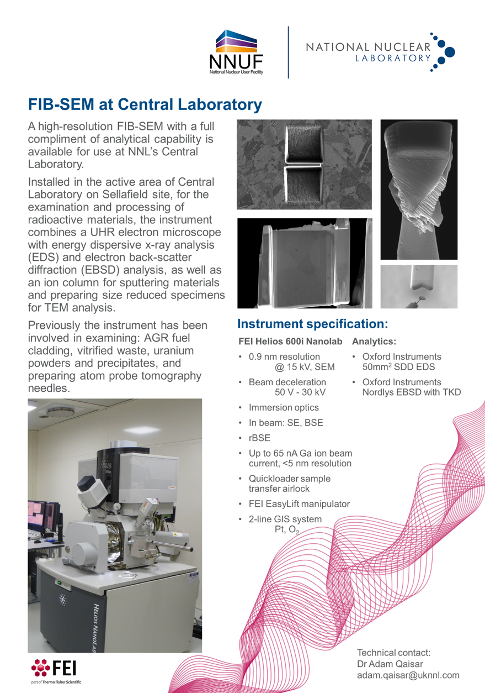
Equipment/Facilities included in this call

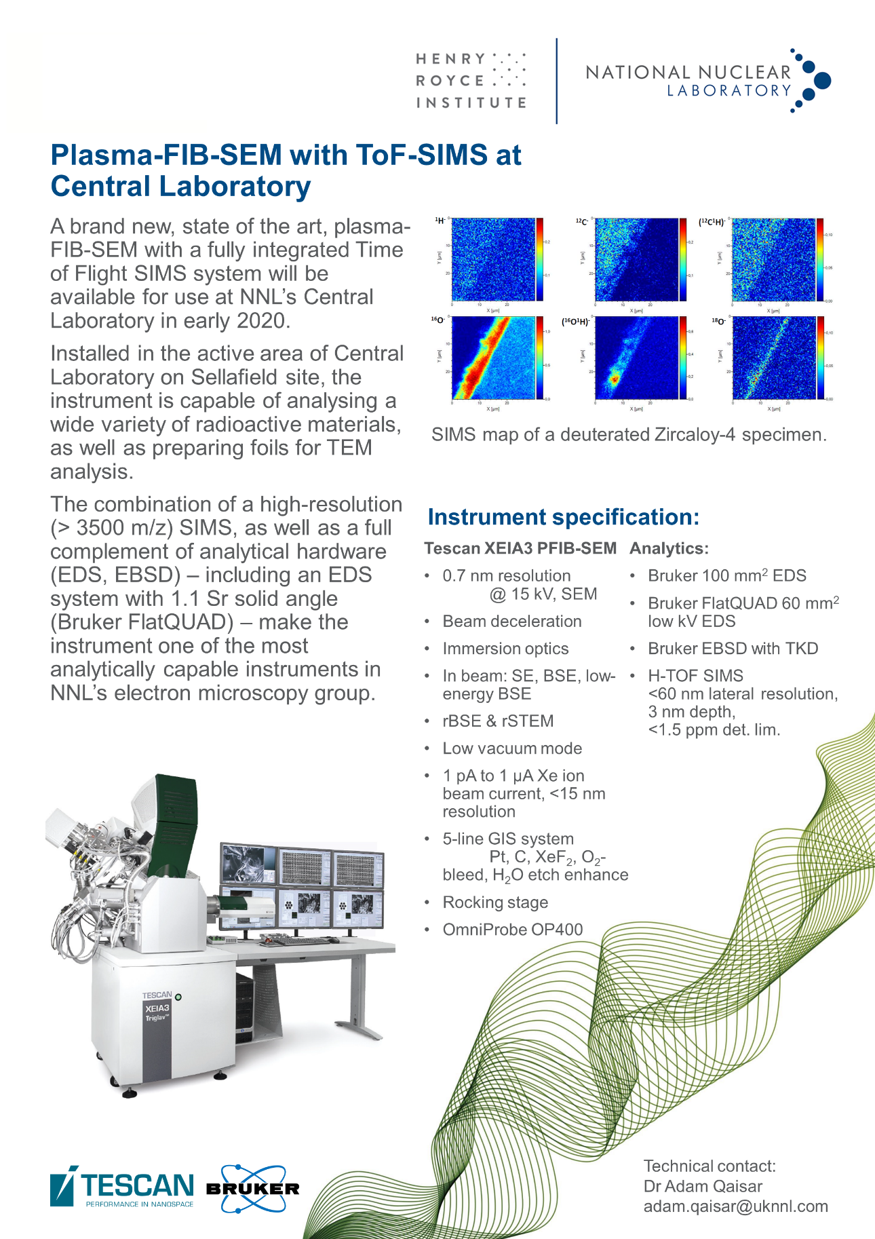

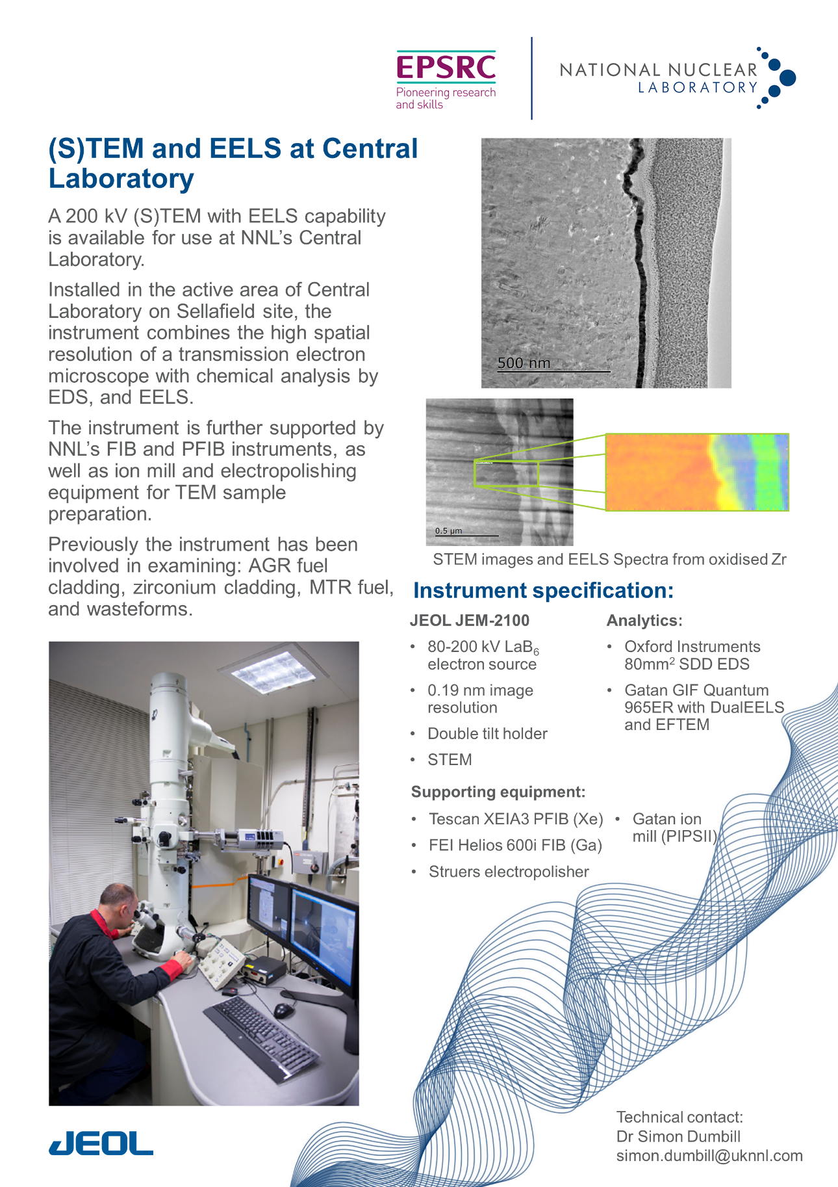

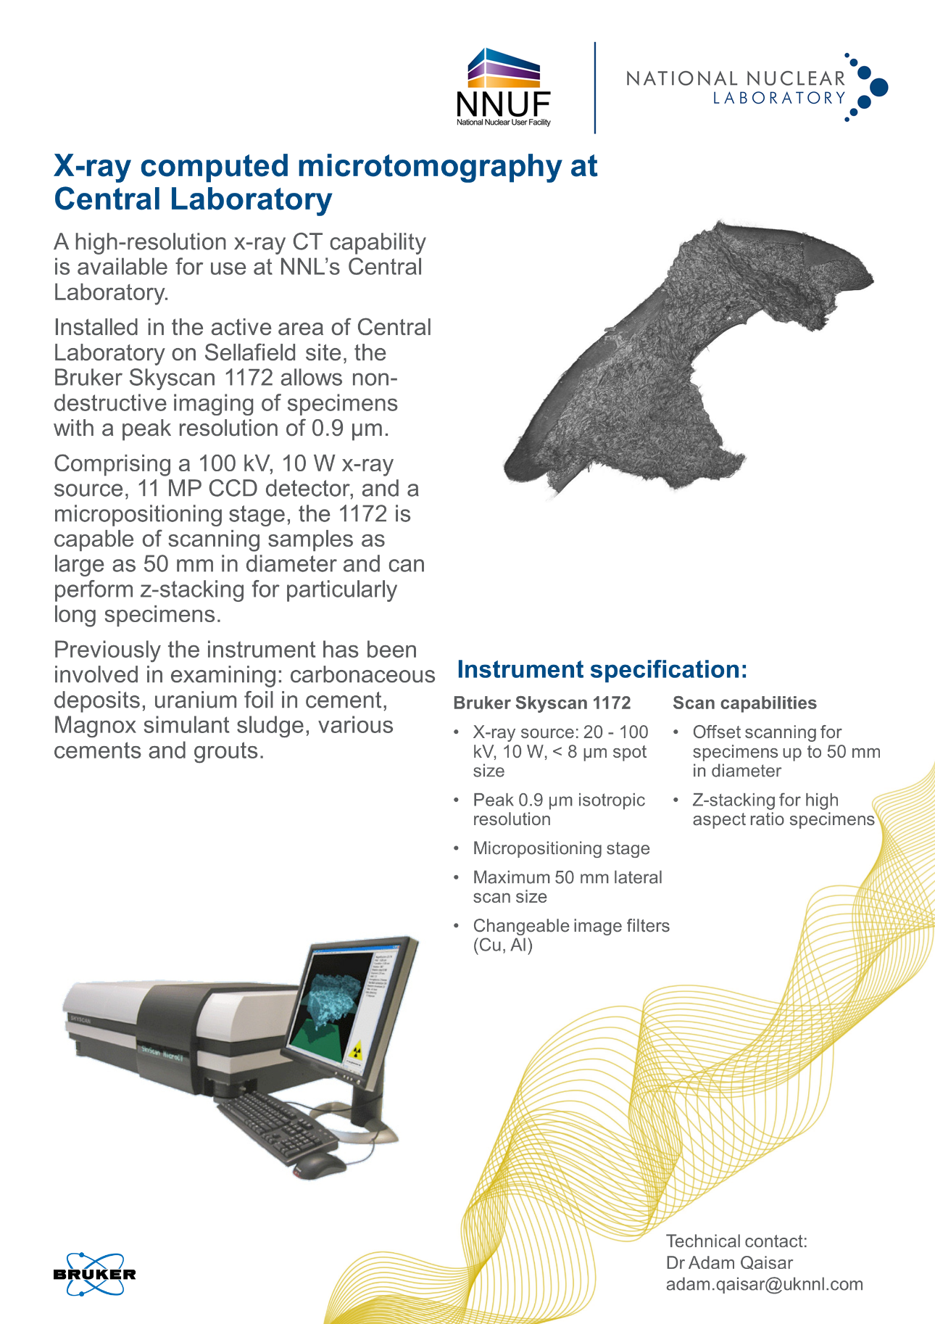

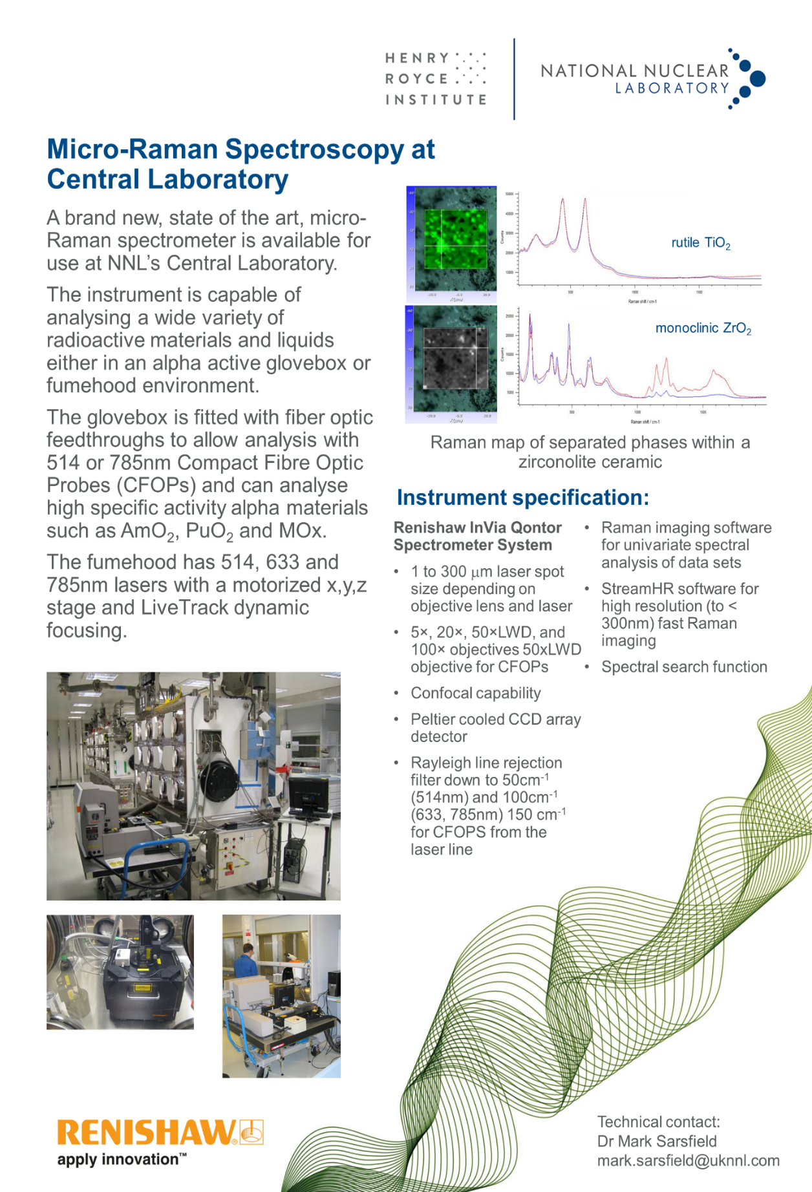

The equipment being made available was procured as part of the National Nuclear User Facility (NNUF), the Henry Royce Institute (HRI) and Engineering and Physical Sciences Research Council (EPSRC) initiatives.
It may be possible to apply for additional funding from NNUF to support sample transfers and T&S. We plan to share further details during the webinar on the 22nd July.

